Press Release
“Come To the Circle”
Wear ORANGE (spirit color)

Indigenous Peoples Day in Washington, DC
Monday October 10th, 2:00-5:00pm EST

For Immediate Release

Event Date: October 10th, 2022

Contact: John Steinbach: johnsteinbach1@verizon.net 703-822-3485 or
Shelia Hansen shoooty@aol.com

American Indian Society of Washington, DC in partnership with Circle Legacy Center, United Tribes of the Shenandoah, and Saving the Circle will host the Indigenous Peoples Day event Where: Adjacent to the National Museum of the American Indian (NMAI) on the National Mall in Washington, DC with speakers, performances, education, activities for children and informational sessions!
Send inquiries to Events@aisdc.org

Partial List of Speakers, Performers, Activities
- Arthur Red Cloud (Navajo) – Actor, “Hikuc” in The Revenant (2015), Behind the Scenes of Revenant
- Harry “Spike” Moss – Activist, Freedom Fighter, Spike Moss on Leonard Peltier
- Barry LeNoir (Chickahominy) – President of The United Black Fund
- Vanessa Petrono (Taino)
- Coalition to Save Historic Thoroughfare
See AISDC website https://www.aisdc.org/ipd2022/ and our Facebook page for more info
Email us at Events@AISDC.com for information on the American Indian Society of Washington, D.C. our mission is to welcome everyone “Come to the Circle”

Sponsored by: 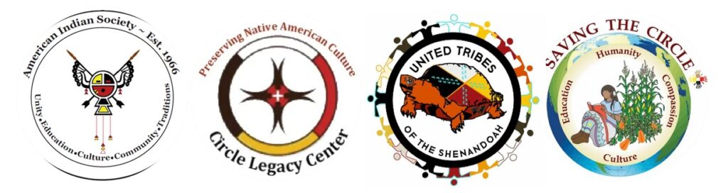
October 10, 2022

